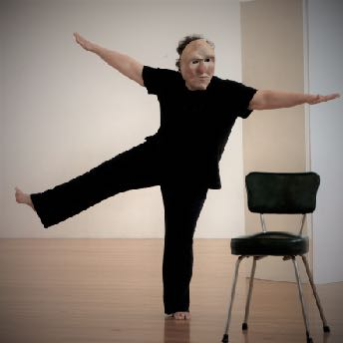

Application Questionnaire

10 Day Theatre Mask Workshop
Please email (beth20man@gmail.com) with the completed questionnaire.
We will let you know as soon as possible if your application is successful.
Please let us know if you have any questions.
—————————————————————————————————
Full Name:
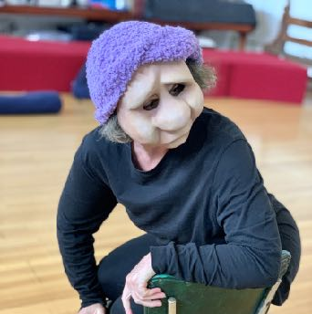


How did you find out about the workshop?

Please tell us a little of why you want to join the workshop? What calls you to it?

What experience do you have in theatre / stage arts / movement?


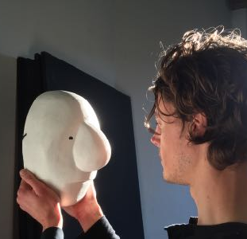

Anything else?

